REPORT
OF
JAVA PROGRAMMING INTERNSHIP
Submitted
To
School of Computer Science and Engineering
IILM University, Greater Noida, U.P.
In partial fulfilment of the requirement of degree of
B.Tech CSE
By
Roll Number of Student: 25SCS1003004673
Name of Student: AMAN KUMAR
Batch: 2026-27

2026-27
CANDIDATE’S DECLARATION
I, AMAN KUMAR, do hereby declare that the internship report titled “Java Programming Internship” has been completed by me to fulfil the requirement for the award of the degree of Bachelor of Technology in CSE. The work presented in this report is based on my internship experience with CodeAlpha. All references used in preparing this report have been acknowledged appropriately. I affirm that this report is my own work and has not been submitted to any other institute for any degree or diploma requirement. I shall be solely responsible for any kind of copyright violation in this regard.

Signature
AMAN KUMAR
Roll No.: 25SCS1003004673

ACKNOWLEDGEMENT
I would like to express my sincere gratitude to CodeAlpha for providing me with the opportunity to undertake a Java Programming Internship. This internship gave me practical exposure to programming-oriented tasks and helped me understand how theoretical concepts can be applied while working on practical assignments and applications.
I am thankful to the people associated with the internship program for their guidance, support and constructive feedback throughout the internship. The experience helped me improve my programming practice, problem-solving approach and understanding of software development workflows.
I also express my gratitude to the School of Computer Science and Engineering, IILM University, Greater Noida, for providing an academic environment that encouraged me to gain practical industry exposure. I am equally grateful to my parents for their continuous support and encouragement.

Signature
AMAN KUMAR
Roll No.:25SCS1003004673

TABLE OF CONTENTS
Chapter No. | Chapter Name | Page Nos.
1 | Candidate’s Declaration | i
2 | Acknowledgement | ii
3 | Internship Completion Certificate | iii
4 | Project Description | 1
4.1 | Introduction | 1
4.2 | Organization Profile | 2
4.3 | Problem Statement | 3
4.4 | Project Objectives | 3
4.5 | Scope of the Internship | 4
4.6 | Technologies and Tools Used | 5
4.7 | System Architecture / Workflow | 6
4.8 | Methodology | 7
4.9 | Expected Outcomes and Learning Outcomes | 8
4.10 | Certificates and Communication Proof | 9
5 | Bibliography / References | 10

INTERNSHIP COMPLETION CERTIFICATE

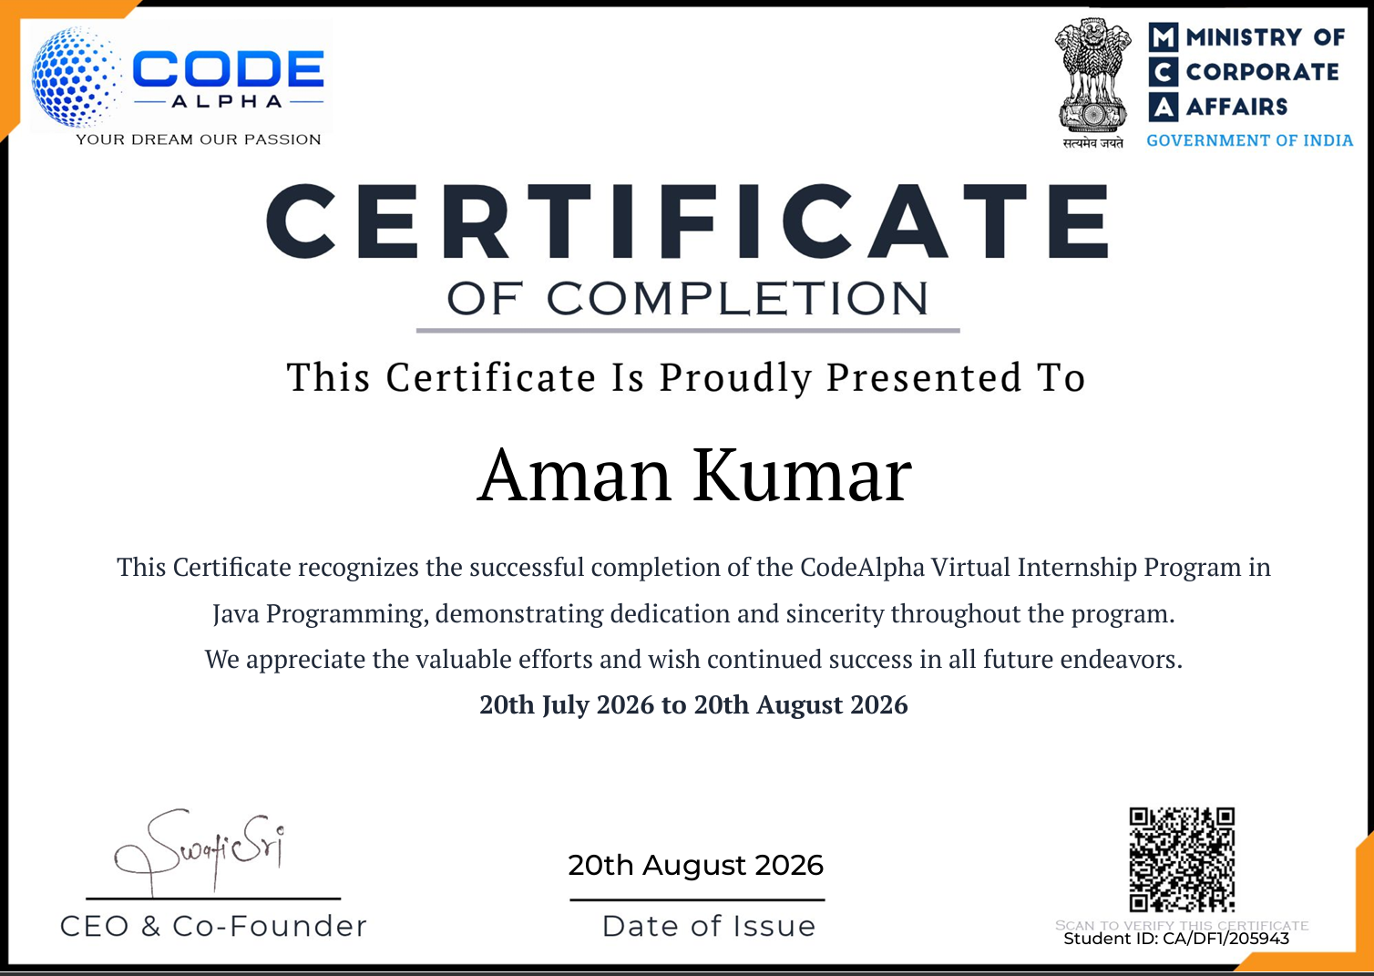

INTERNSHIP OFFER LTTER
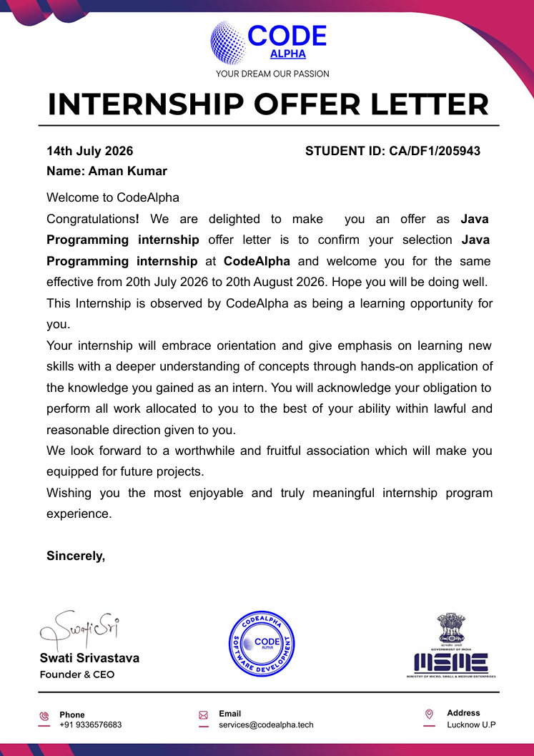

TASKs

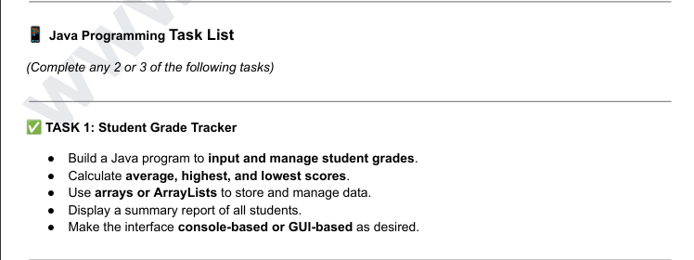
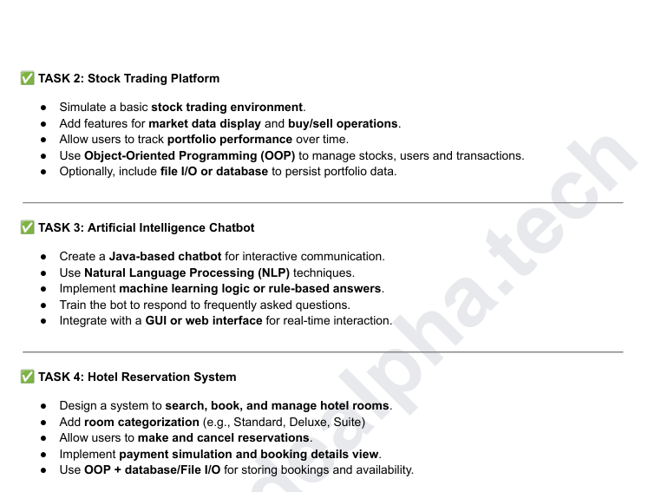

4. PROJECT DESCRIPTION
This report presents the work and learning experience gained during a “Java Programming Internship” at CodeAlpha. The internship was undertaken for approximately four weeks, from 20 July 2026 to 20 August 2026. The internship was conducted in a virtual, assignment-based format, allowing the intern to work on practical programming activities while developing technical and problem-solving skills.
The primary focus of the internship was Java programming. The experience was intended to strengthen programming fundamentals, object-oriented programming concepts, application-oriented thinking, debugging and systematic problem solving. The internship also provided an opportunity to practice completing technical tasks independently and presenting the resulting work in a structured manner.

4.1 INTRODUCTION
Internships are an important part of technical education because they provide an opportunity to connect academic knowledge with practical work. A programming internship allows a student to move beyond classroom examples and practice writing, testing, debugging and improving programs for defined requirements.
During this internship, I worked in the Java Programming domain with CodeAlpha. The internship followed a practical, assignment-oriented approach. I used the internship period to strengthen my understanding of Java programming, apply programming concepts to practical tasks and improve my ability to identify and resolve errors.
The overall experience helped me understand that software development requires more than writing code. It involves understanding requirements, selecting an appropriate approach, implementing a solution, testing it, correcting errors and documenting the final work.

4.2 ORGANIZATION PROFILE
CodeAlpha is a technology-focused learning and internship platform that provides virtual internship programs, practical coding assignments and project-oriented learning opportunities. According to its official website, the internship model is assignment-based and is designed to provide learners with practical exposure rather than passive learning.
The organization offers internship tracks across multiple technical domains, including Java Programming. Its internship journey involves receiving an internship opportunity, completing assigned tasks or projects, submitting the work for evaluation and receiving certification after successful completion of the required work.
The virtual structure of the internship provided flexibility while still requiring regular practical work. This format was useful for developing self-learning, time management and independent problem-solving habits alongside technical programming skills.
For this internship, the selected domain was Java Programming and the internship duration was from 20 July 2026 to 20 August 2026.

4.3 PROBLEM STATEMENT
A common challenge for students learning programming is the gap between understanding programming concepts theoretically and applying those concepts to practical tasks. Students may know syntax and definitions but still face difficulty when they need to design a solution, break a problem into smaller steps, implement the logic and debug the resulting program.
The internship addressed this learning gap through practical, assignment-based programming work. The problem therefore can be stated as: to apply Java programming concepts in practical tasks and improve the ability to develop, test and refine software solutions independently.

4.4 PROJECT OBJECTIVES
- To strengthen core Java programming knowledge through practical implementation.
- To improve understanding of object-oriented programming and structured problem solving.
- To practice writing readable, maintainable and logically organized programs.
- To develop debugging and error-resolution skills through hands-on programming.
- To improve the ability to understand task requirements and convert them into working solutions.
- To gain experience with an assignment-based software development workflow.
- To build confidence in completing programming tasks independently.

4.5 SCOPE OF THE INTERNSHIP
The scope of the internship was focused on Java programming and practical software development activities. The internship provided an opportunity to practice programming concepts in an applied environment rather than limiting learning to theoretical exercises.

Technical Scope
- Java programming fundamentals and syntax.
- Object-oriented programming concepts and structured program design.
- Problem solving using logical decomposition and step-by-step implementation.
- Input/output handling and basic application development concepts where required by tasks.
- Testing, debugging and correcting programming errors.
- Writing organized code and maintaining a clear development workflow.

Professional Scope
- Working independently on assigned tasks.
- Managing time during a fixed internship period.
- Submitting completed work in a structured manner.
- Improving communication and documentation skills.
- Building practical confidence for future software-development projects.

4.6 TECHNOLOGIES AND TOOLS USED
Technology / Tool | Purpose | Learning / Use
Java | Primary programming language | Developing and implementing programming solutions.
Object-Oriented Programming | Program design approach | Applying classes, objects and reusable program structure.
JDK / Java Development Environment | Compilation and execution | Writing, compiling and running Java programs.
VS Code / IDE | Code development | Editing, organizing and testing source code.
Git / GitHub (where applicable) | Version control and project sharing | Managing and presenting programming work.
Web Browser | Reference and verification | Accessing internship resources and technical documentation.
The exact tools used for individual assignments may vary depending on the task requirements. The core technical focus of the internship remained Java programming and practical problem solving.

4.7 SYSTEM ARCHITECTURE / WORKFLOW
Since the internship consisted of programming assignments rather than one single large production system, the overall workflow can be represented as a general software-development process.
Stage | Description
1. Requirement Understanding | Read the assigned task and identify expected inputs, processing and outputs.
2. Problem Analysis | Break the problem into smaller logical steps and select a suitable programming approach.
3. Design | Plan classes, methods, variables and program flow where required.
4. Implementation | Write the Java program and implement the required functionality.
5. Testing | Run the program with different inputs and check whether the expected results are produced.
6. Debugging | Identify syntax, logical or runtime issues and correct them.
7. Review & Submission | Review the final solution, organize the files and submit the completed work.
This workflow helped establish a repeatable approach to programming tasks. It also reinforced the importance of testing and debugging rather than considering the task complete immediately after writing the first version of the code.

4.8 METHODOLOGY
The internship used a practical, task-oriented methodology. Each programming task was approached through a sequence of understanding the requirement, planning the solution, implementing the code, testing the result and correcting errors.

Step 1: Understanding the Requirement
The first step was to understand what the task required, what inputs were expected, what output or behaviour was required and what constraints needed to be considered.

Step 2: Planning the Solution
After understanding the requirement, the problem was divided into manageable parts. Appropriate Java constructs, classes, methods and control structures were considered before implementation.

Step 3: Implementation
The planned solution was converted into Java source code. Attention was given to logical structure, readability and correct use of programming concepts.

Step 4: Testing and Debugging
The program was executed with test inputs to identify syntax, runtime or logical issues. Errors were analyzed and the code was modified until the expected behaviour was achieved.

Step 5: Review and Documentation
The completed work was reviewed before submission. This stage helped ensure that the solution was understandable, organized and ready to be presented as internship work.

4.9 EXPECTED OUTCOMES AND LEARNING OUTCOMES
The internship was expected to provide practical exposure to Java programming and help bridge the gap between academic concepts and applied programming. The major learning outcomes are summarized below.
- Improved confidence in writing Java programs.
- Better understanding of object-oriented programming and structured program design.
- Improved logical thinking and problem-solving ability.
- Greater familiarity with debugging and testing.
- Improved ability to understand and implement technical requirements.
- Better time management while completing assigned programming tasks.
- Experience with a practical, assignment-based development workflow.
- Improved readiness for future academic and software-development projects.

Overall Outcome
The internship provided useful practical exposure to Java programming and helped reinforce programming knowledge through hands-on work. It also encouraged independent learning, systematic debugging and disciplined task completion.

4.10 CERTIFICATES OF COMPLETION AND OTHER COMMUNICATION MAIL PROOF

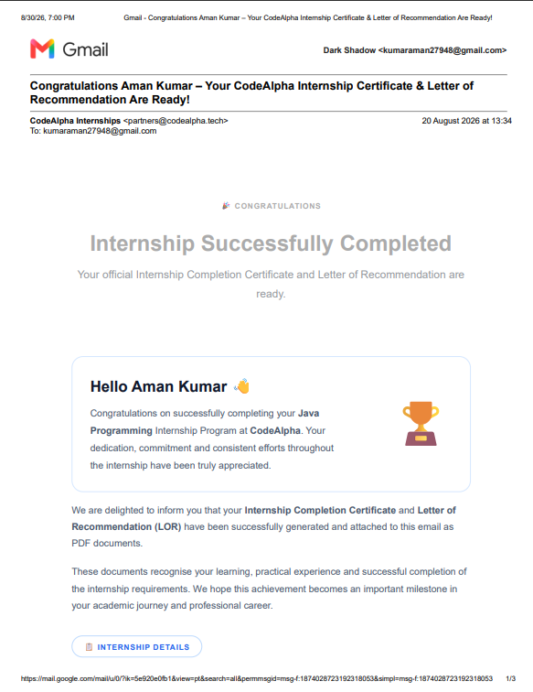

5. BIBLIOGRAPHY / REFERENCES
CodeAlpha. Official Website and Internship Program Information. https://www.codealpha.tech/
Oracle. Java Documentation and Java Platform Documentation. https://docs.oracle.com/en/java/
Oracle. The Java Tutorials / Learning Resources. https://docs.oracle.com/javase/tutorial/

APPENDIX: INTERNSHIP DETAILS
Student Name | AMAN KUMAR
Roll Number | 25SCS1003004673
University | IILM University, Greater Noida, U.P.
Degree | B.Tech CSE
Batch | 2026-27
Organization | CodeAlpha
Internship Domain | Java Programming
Internship Role | Java Programmer / Java Programming Intern
Internship Period | 20 July 2026 – 20 August 2026
Mode | Virtual Internship

